Common Interest between You and Me: Investigating Common Interest among Developers in GitHub Pull Requests

Sunbin Park and Eunjoo Lee*

School of Computer Science and Engineering, Kyungpook National University
80 Daehakro, Bukgu
Daegu, Republic of Korea
sbp831@naver.com, ejlee@knu.ac.kr

Abstract

In software development, building a cohesive team can create great synergy in software development work. In the case of open source software development, difficulties occur in forming a cohesive team because information about developers is limited. Therefore, research into building cohesive teams using information available from open sources is required. In this study, we investigate the similarity of interest among developers with an active collaborative relationship in GitHub.

Keywords- common interests; GitHub; pull-request; developer social network; collaborative ties

I. Introduction

Open source software (OSS) is shareable software that can be used, modified, and distributed by anyone using open source code. Depending on the scale, many developers around the world often participate in a project and co-develop it. A team that is cohesive in software development is much more productive and motivated than is a general team [1]. However, open source project teams are geographically dispersed, making direct communication difficult. Therefore, forming a cohesive team in open source project development is difficult.
No function exists for forming a cohesive team. However, various studies have been conducted on software teams in efficient collaboration [2, 3, 4]. Kotlarsky et al. [2] confirmed that relationships and interactive storage are essential to software development collaboration. Black et al. [3] determined that social media enables smooth communication in software system development. Ray et al. [4] studied GitHub to analyze the relationship between the programming language used by the developer and the GitHub contribution.
Members of a cohesive team share a common goal, common culture, and, in many cases, a kind of elite ritual that makes them feel special [1]. If collaborative developers have similar interests as those that are not in a collaborative relationship, a developer with a common interest may have a greater sense of cohesion than a non-collaborative developer. GitHub is a popular open source code repository. GitHub collaborates based on pullrequest functionality. Pullrequest is a feature that suggests modifications to code created by others. Interested developers contribute to these modifications by providing comments to verify the proposed pullrequest. Therefore, comment information left by developers in pullrequests can be used as important information to confirm collaboration among developers.
In this study, we propose a method to measure the similarity of interest of collaborative developers. First, we generate a developer collaboration graph (DCG) using developer comment information contained in pullrequests. In DCG, the developer is represented by a node, and the number of repositories containing pullrequests commented collaboratively is represented by an edge. If no edge exists between two developer nodes in the DCG, then the two developers have never been in a collaborative relationship. Therefore, DCG can intuitively identify developers with and without collaborative relationships. The similarity of interests of collaborative developers can be determined based on the similarity of the GitHub repositories in which each developer is interested. For example, if two developers are interested in a set of GitHub repositories, those developers are likely to have the same interests. An interest similarity test can be administered that uses summary information from the GitHub repositories of interest to the developers. <Fig. 1> shows an example of the GitHub repository summary information. Natural language processing such as elimination of negatives and stem extraction can be applied to summary information about the repository, and then a word list for each developer can be extracted. The word list consists of summary words in the GitHub repository. Therefore, we can calculate the similarity of two developer interest vectors using a cosine similarity calculation [5].

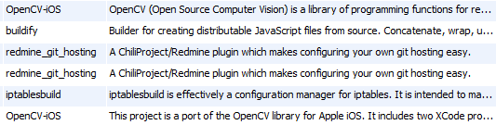
Fig. 1 Summary information of the GitHub repository.

This study improves the skills necessary to build a cohesive development team. The major contributions of the study are as follows.

- We configure an interest vector for each developer by mining repository subscription information.
- We measure the degree of interest similarity between developers who have collaboratively commented on pullrequests using a constructed interest vector.

This remainder of this paper is organized as follows. Chapter 2 describes our creation of a DCG to intuitively identify collaborative relationships. Chapters 3 and 4 show the results of the similarity analysis of interest of collaborative developers. Chapter 5 provides a conclusion.

II. Developer Collaboration Graph

In this chapter, we describe the processing of creating a DCG to identify collaborative developers easily.

A. GitHub Pullrequest

Here, we describe the GitHub pullrequest, which is the foundation of DCG generation. A pullrequest represents the core of collaboration in GitHub. In GitHub, the developer forks the master branch of the project and changes itself. A fork is a function that copies the source code to its own branch. Thus, a unique branch created by a fork can be changed without affecting the master branch. When someone is ready to submit his or her changes to the master branch, one can send a pullrequest. The process of sending the pullrequest is shown in <Fig. 2>. When a person sends a pullrequest to the master branch, interested contributors review the code to verify the submitted pullrequest. If a pullrequest does not meet the standards or requires further improvement, the submitter can update the pullrequest by adding a new commit. During this process, all comments can be reviewed and discussed until the pullrequest is closed. When the code review is completed and verified, it is reflected in the master branch.
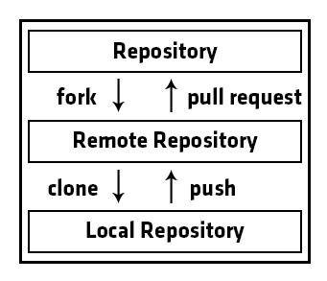
Fig. 2 Pullrequest submission process.

TABLE 1. Natural language processing results
Original  words | End user-oriented web performance testing and beaconing
Words after natural language process | end user orient web perform test beacon
B. Creating a developer collaboration graph

This section describes how we generate a DCG based on GitHub's pullrequest comment information. A DCG is created as a project with a pullrequest code review by general developers and developers of D = {d1, d2, ..., dn}.
Developers who have participated in the code review of pullrequests can see the pullrequest comment information. For example, if developers who commented on pullrequest pr are d1, d2, and d3, then d1, d2, and d3 are the developers who participated in pullrequest pr. The DCG consists of a developer node participating in a pullrequest and a project edge representing pullrequests jointly participated in by the developer. The edge of the DCG is represented by a weighted edge and the weight of the project edge is determined by the number of pullrequests involved. For example, if three projects exist that have a pullrequest code review with two developers, the weight of the project edge between the two developers is three.

III. Common Interests Among Co-Participant Developers

The proposed developer interest similarity measurement method extracts developer interest from information about the projects of interest in word-vector form. Then, a word-vector similarity between the developers is obtained and a common interest is confirmed. The process is described in more detail as follows. First, information about the projects of interest to developers is extracted. Next, a word list for each developer is generated through natural language processing. Then, the word list similarities among developers are determined through a cosine similarity calculation. Each step of this process is described in detail in the following section.

A. GitHub Watch

GitHub has a feature called Watch. Using this function, users of GitHub can receive notifications about repository events such as new commits, pullrequests, and artifacts from the public repository. This can be considered as a kind of manual membership registration. Thus, subscribing to a repository represents a declaration of potential interest in contributing to the activities of the repository [6].

B. Extract interest vectors of developers

We created a vector of interest for each developer based on the descriptions of the repositories the developer is currently watching. Because the description is composed in natural language, extracting only meaningful words is necessary. First, we convert all uppercase letters to lowercase letters in words extracted from the text of the description. We then remove words that denote a negation and that are thus considered meaningless. When the removal of these negatives is completed, another segment extraction is performed. In this study, we use the stem extraction algorithm developed by Porter to transform words that can have several forms into their original form. The results of this natural language processing are listed in <TABLE 1>.
The aforementioned process must be performed in order to create more meaningful word lists for developers. The word list generated for each developer is a vector having N elements, each of which is composed of description words. The value of the element is denoted by the term frequency (TF) (t, d), representing the occurrence frequency of word t in the word list of developer d.

C. Extract interest vectors of developers

Each developer-specific word list obtained through the process described previously is used to check the similarity of developer pairs. The word list is similar to the feature vector for a word. Therefore, in this study, we define the similarity value between developer word lists by the following equation based on cosine similarity calculation [5].

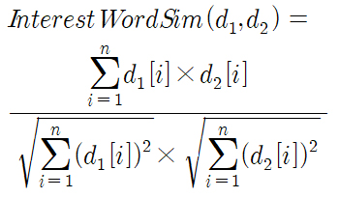 (1)

where d1 and d2 are developer word lists, n is the total number of words, and d1 [i] and d2 [i] are the TF values of the i-th word of the developer word list. Equation (1) calculates the similarity value of word lists of two developers.

TABLE 2 Collected datasets of the Ruby on Rails project
Dataset | #
Pull Requests | 16501
Forked Projects | 13877
Authors | 1519
Commenters | 1196

IV. Experimental results

A. Dataset

We chose the Ruby on Rails project developed by GitHub as an experimental dataset. We included a project that forks a Ruby on Rails project as an experiment. The Ruby on Rails project is summarized in <TABLE 2>.
We selected pullrequest 4403699, which has the most code reviews in the target project. Ten total developers have written 189 comments in pullrequest 4403699. In this study, we did not utilize the author information of the pullrequest because it is based on the collaborative relationship between commenters. Ten developers commented on the pullrequest in a total of 1618 repositories. Of these repositories, 229 stores, or 14.15%, commented on the same pullrequest as one or more of the other nine commentators. <Fig. 3> shows 10 DCGs for participation in pullrequest 4403699.

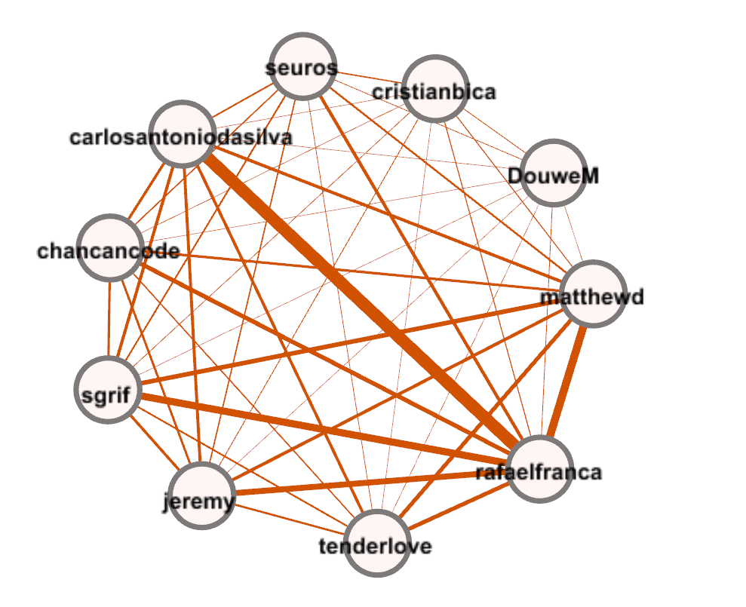
Fig. 3 Collaboration of developers participating in pullrequest 4403699.

B. Relationship between collaboration and interest similarity

We next compared the similarities of the developers who do not have a collaborative relationship with the project similarity of the collaborating developers. The comparators were selected by the developers who participated in the project called symfony. We extracted six developers who had collaborative relationships while working on the symfony project but who did not have a collaborative relationship with developers who participated in pullrequest 4403699. <Table 3> shows the average cosine similarity of interest vectors for pairs of developers that have collaborative relationships. The average vector similarity of the collaborative developers was 54.9%, and the average vector similarity of interest between the non-collaborating developers was 25.3%. The following results show that collaborative developers have a high average interest vector similarity. In other words, collaborative developers share common interests.

TABLE 3 Average interest vector similarity
Repo1 | Repo2 | %
Ruby on Rails | Ruby on Rails | 41.0
Ruby on Rails | Symfony | 25.3
Symfony | Symfony | 68.8

V. Conclusion

Based on pullrequest comment information from GitHub, we investigated common interests among developers with collaborative relationships. First, we created a DCG based on the developer comment information contained in pullrequests. The generated DCG identified developers with collaborative relationships. A developer interest vector was then generated based on the description of the GitHub repositories of interest to the developers. The similarity of interest vectors among the developers was calculated using the cosine similarity measurement. Experiments on the Ruby on Rails project developed by GitHub confirmed that developers with collaborative relationships identified through the DCG share common interests. We plan to conduct an in-depth analysis of developer common interests in various open source projects in the near future.

Acknowledgments

This study was supported by the BK21 Plus Project (SW Human Resource Development Program for Supporting Smart Life), funded by the Ministry of Education, School of Computer Science and Engineering, Kyungpook National University, Korea (21A20131600005). It was also supported by the Basic Science Research Program through the National Research Foundation of Korea (NRF), funded by the Ministry of Education, Science and Technology (2012R1A1A3011005).

References

[1] T. DeMacro, and T. Lister, Peopleware: productive projects and teams, 3rd ed., Addison-Wesley, 2013.
- J. Kotlarsky, and I. Oshri, "Social ties, knowledge sharing and successful collaboration in globally distributed system development projects," European Journal of Information Systems, vol. 14(1), pp. 37-48, March 2005.
- S. Black, R. Harrison, and M. Baldwin, "A survey of social media use in software systems development," Web2SE, pp. 1-5, May 2010.
- B. Ray, D. Posnett, V. Filkov, and P. Devanbu, "A large scale study of programming languages and code quality in github," FSE, pp.155-165, November 2014.
- P. N. Tan, M. Steinbach and V. Kumar, Introduction to Data Mining, 1st de., Addison-Wesley, 2005.
- L. Dabbish, C. Stuart, J. Tsay, and J. Herbsleb, "Social Coding in GitHub: Transparency and Collaboration in an Open Software Repository," CSCW, pp.1277-1286, 2012.

https//github.com *corresponding author
https://snowball.tartarus.org
https://rubyonrails.org
https://symfony.com

